2018-2019 EDUCATION YEAR
ÇAĞLAYAN SECONDARY SCHOOL CLASS 8th GRADES
ENGLISH LESSON 1ST TERM 1ST WRITTEN EXAM

NAME-SURNAME :
NUMBER :

PART A: Read the conversation and complete the blanks with the sentences below (4×2=8pts.)
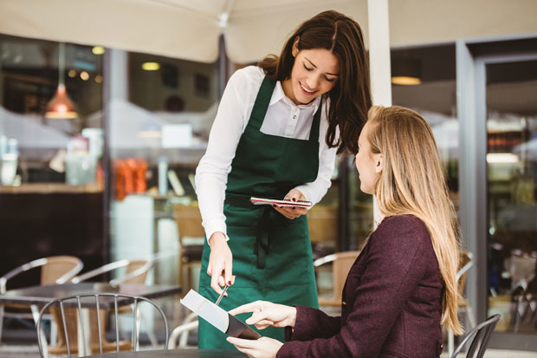
-Alright! Anything else?
-Would you like anything to drink?
-Hello! May I take your order?
-Sure. Would you like to have a dessert?

Waitress : .................................................................. (1)
Woman : Yes, please. I’d like a hamburger, please.
Waitress : .................................................................. (2)
Woman : Well, can I take soda, please?
Waitress : .................................................................. (3)
Woman : Yes. I’d like a piece of chocolate cake.
Waitress : .................................................................. (4)
Woman : That’s all for the moment. Thank you.
https://www.sorubak.com
Part B : Match the words with their definitions (10×2=20pts.)
1 | trendy | ..... | a | informal conversation about daily matters
2 | unbearable | ..... | b | someone who has no respect to people in the lower  social classes
3 | honest | ...... | c | to give encouragement to someone
4 | casual | ..... | d | to explain why you refuse an invitation
5 | snob | ..... | e | something that you can’t stand
6 | support | ..... | f | very fashionable
7 | full | ..... | g | to have a power to effect the mind or feeling
8 | chit-chat | ..... | h | daily,ordinary
9 | excuse | ..... | i | not hungry
10 | impressive | ..... | k | someone always telling the truth
Part C : Read the text and answer the questions (5×3=15pts.)
BEING A TEENAGER IN THE USA
About 7000 high school and college students across the USA answered a survey about how teenagers think and feel about some certain issues.
What’s shopping behavior of the teenagers in the USA? 37% of the teenagers go shopping more than twice a month. The teenagers prefer shopping in stores (77.5%) than online (22.5%). The top five items that the teenagers buy are clothing, health & beauty, electronics, music and books.
What goals do the teenagers have? 75.4% of the teenagers set goals for themselves. 41.8% of teenagers see educational goals as the most important. 59% of the teenagers plan to take a vacation with their parents in summer. 38% of the teenagers plan to read nine or more books in summer. 60.4% of the teenagers plan to spend more time for outdoor activities than indoor activities.
Do the teenagers follow the news? 83.5% of the teenagers pay attention to the news. 41.6% of teenagers read the newspaper every day. 35.5% of the teenagers watch TV news at least once per day.

- How many students answered the questions in the survey? .
About 7000 students answered the questions in the survey
- Which one is more popular; shopping in stores or buying online?
.........................................................................................................................................
- What kind of items do the teenagers mostly buy?

..................................................................................................
- What’s the most important type of goals among the teenagers?
.............................................................................................................
- How many books do the teenagers plan to read in summer?
.............................................................................................................
- How often do the teenagers watch TV news?

..........................................................................................................
Part D : Answer the questions about yourself (8×2=16pts.)

1. How do you go to school? .............................................................................
2. Where do you usually have lunch? .............................................................................
3. Who usually helps you with your homework? .............................................................................
4. How often do you surf the Internet? .............................................................................
5. What do you never do in the evenings? .............................................................................
6. How often do you visit your grandparents? .............................................................................
7. When do you usually go on vacation? .............................................................................
8. Who is your buddy ?.................................................................................................

Part E :Read the sentences and put ( I ) for Inviting ; ( A ) for Acceptations, ( R ) for Refuse and ( E ) for Excuses. (14×2=28 pts.)

(….) 1. I am sorry but I can’t. (….) 8. Would you like to come over?
(….) 2. Shall we go to pop concert? (….) 9. I must finish my project.
(….) 3. Why not? I love it. (….) 10. I have some other plans
(….) 4. No, thanks. (….) 11. That sounds bad.
(….) 5. That would be great! (….) 12. I feel tired.
(….) 6. How about going on a picnic? (….) 13. Cool! I’ll be there.
(….) 7. Sure, it sounds awesome. (….) 14. I have to stay at home.

Part F : Write the Turkish meanings of the words (13×1=13 pts.)
I prefer listening to rock music. To me, it is exciting. My best friend likes opera. I think it is boring and unbearable. I can’t stand it.

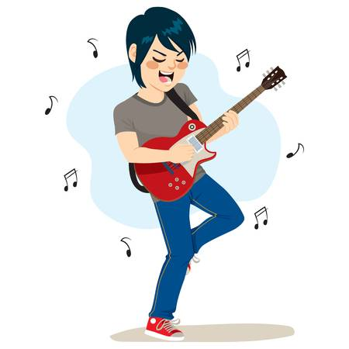

- Prefer : 2: To me :
“ 3. Unbearable : 4. Can’t stand :


My favorite activity is reading books. I like detective and travel books. My brother recommends me biographies, but I think they are boring.

5.travel boks :
6.recommend :

I am interested in sports. I attend sport club. I go to gym twice a week. I exercise and try to keep fit. I also like camping with my friends. Sitting around the fire and sing songs are my favourite parts of camping.

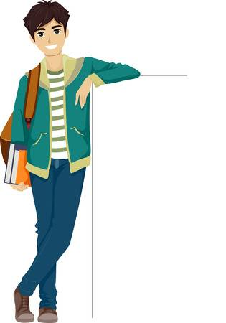

7.Interested in : 8.attend :
9. gym: 10. Exercise :
11. Exercise : 12. Keep Fit:
13. Sitting around the fire :



Naciye ÖZMEN AY
English Language Teacher

